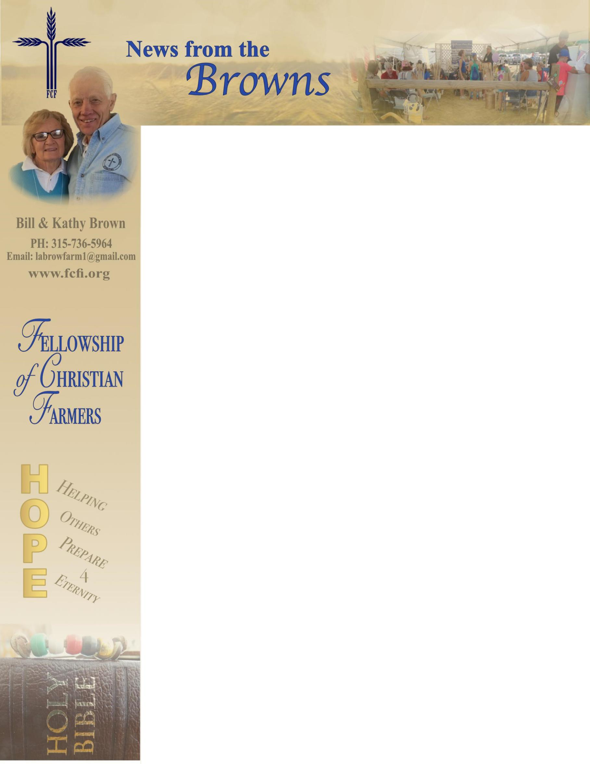

January 2020

Greetings to all,

**Isaiah 40:30-31” Even youth grow tired and weary, and young men stumble and fall; but those who hope is in the Lord will renew their strength. They will soar on wings like eagles; they will run and not be weary, they will walk and not faint.”** One of my favorite old testament scriptures. It seems to highlight the stages of life – youth – “soar like eagles, middle age – “run and not be weary”, seniors “walk and not faint.” Kathy and I are in the later stage, a good place to be when serving the Lord. We don’t go quite as fast but certainly are not fainting. God has been so good to us in 2019 and we look forward to 2020 as we start our 21st year of serving through FCF. Giving people HOPE, the hope that only comes from knowing Christ as Savior.  
 I (Bill) will be back in the north country for 10 days in January working the Keystone Farm Show in York, PA and catching up on a few things. Back to Florida the middle of the month and the start of a very busy show season here in the south. There will be events in the northeast being covered by the fieldmen. We’ve attached our anticipated 2020 event schedule; we’re always adding new events as doors open. We can’t thank you enough for your prayers and support.   
 On our way back to NY, the first of April, we stop over in SC to work the Flowerton Festival in Summerville. If there’s an event close to you or your travels, we’d love to have you join us. Our goal for 2020 is to play a role in sharing the gospel with 50,000 people.   
 So, for now, we continue to ask for prayer as we travel, for all our helpers and for God to continue to guide and lead us. Our information is included, please feel free to contact us if you have any questions or have an event close to your home that you would like us to have a presence. Remember, “**The fields are white ready for harvest.” John 3:35.**

Partnering with you for Him,

Bill and Kathy Brown - Your FCF Missionaries