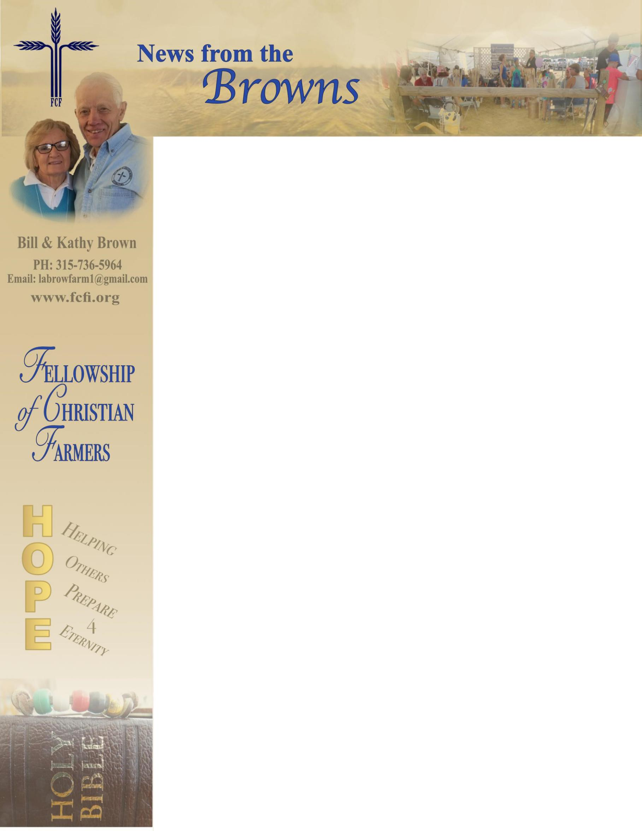

April 30, 2019

Greetings to all,

**1 Timothy 2:3&4 “This is good, and pleases God our Savior, who wants all people to be saved and to come to come to a knowledge of the truth.”** This mornings devotion Ezekiel 33:1-11 empathizes our responsibility to “blow the horn,” we are not responsible for the results. God takes care of that. As we finish our spring schedule and are back home in NY we have done our best, over 5,700 people of all ages heard the gospel. We worked at events nearly every week and we’re so thankful for all who helped us during this busy season. Hundreds have responded by accepting Jesus as their Savior. Two young men stopped by at two events in Florida expressing their thanks to us for being there. It seems at last years event, they accepted Christ as their Savior. It’s always good to hear that people are continuing on their walk with the Lord.   
 I ran across the following while working in PA. this past January. “The further a culture gets from the truth, the more they hate those who speak it.” Sounds like our country doesn’t it? WE run across folks like that from time to time but we continue to share the truth with the hope that God will change hearts.   
 We’re still trying to adapt to this late spring but at least we do not have to deal with snow. In April we had the privilege of attending the Fellowship of Christian Farmers - Canada Conference. WE are so proud of of the staff and many volunteers who make FCF-C work. They continue to grow and sound the trumpet.   
 Our time is being spent in preparing for the upcoming summer and fall schedule. There are two major events on the calendar for July. The **Eastern Summer FCFI Conference** is scheduled for July 12-14 right here in central NY. I hope you can find time to join us. Give us a call if you’d like more information, we have a wonderful line up of speakers on the program. Also, our annual **Walking Stick Work Days** is scheduled for the following week. We can use your help as we prepare for the summer schedule. Once again, thanks for your prayers and support.  
 Partnering with You for HIm,  
  
 Bill and Kathy Brown - Your FCFI Missionaries