January 8, 2019

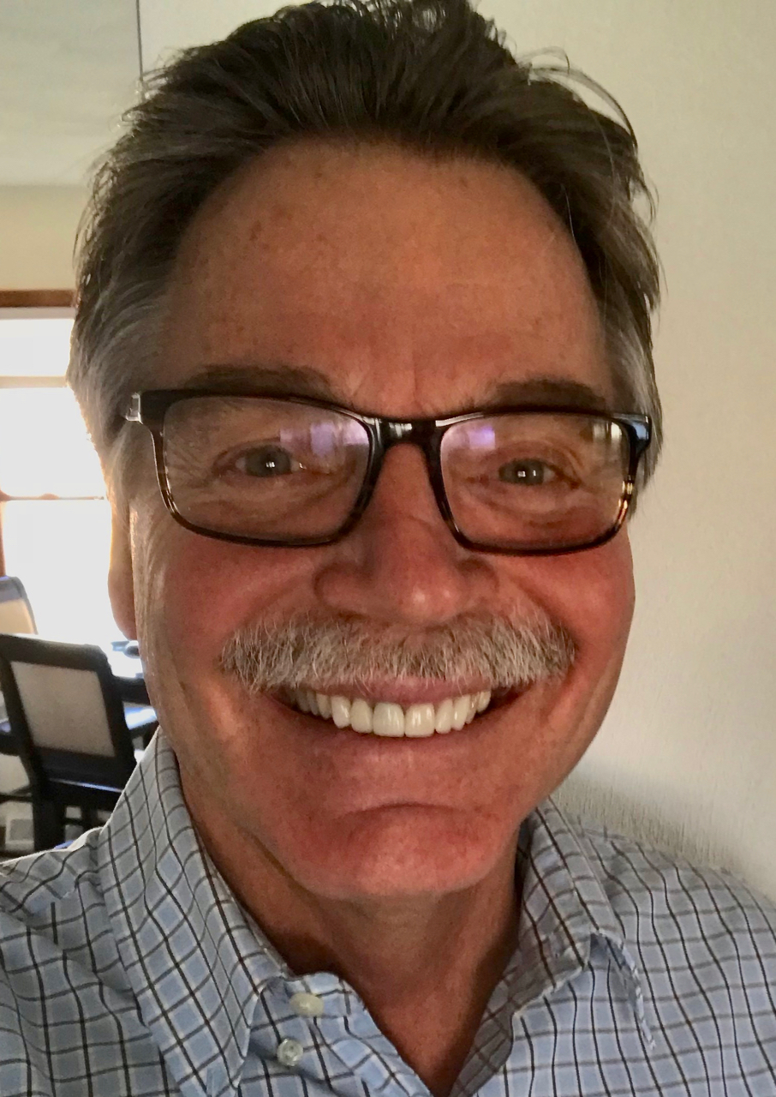

Fellowship Of Christian Farmers, Intrnational

Hello. My name is Kevin Cernek. I am a pastor and a farmer from Wisconsin. If all goes well I will be contributing to this great website on a regular basis. Let me give a little background about myself so you know who I am. I was born in Valparaiso, Indiana and spent the first 13 years of my life on a dairy farm just outside a tiny town called Boone Grove. As a kid, I worked everyday alongside my dad and brothers and my Grandpa. Grandpa’s “day job” was working at a steel mill in East Chicago as a self-taught plumber and electrician. He had only one goal in life: to see his son, (my dad), succeed as a dairy farmer.

Grandpa loved us kids and we knew it. He worked second shift at the mill getting home well past midnight every night. But at six o’clock in the morning he was up eating a bowl of Cream of Wheat cereal with a slice of dark, Jewish pumpernickel bread on the side. The first half of his bread he ate dry. But the second half was slathered in butter and topped with about a half inch of jelly. He would wash it down with a couple of chugs of buttermilk right out of the carton. That was his breakfast ritual. Then he headed out the door to feed and care for dad’s herd of black angus cattle which he was raising on the side at a different location from the home farm, to supplement his dairy income a little.

I have six brothers and one sister. I fall in the sibling order at number four. My oldest brother is four years older than me, my youngest (and only sister) is 17 years younger. She came along last. After seven boys Mom finally had her girl.

When school was in session, my brothers and I got up early and did our chores before breakfast and the bus. My wind-up alarm clock was set to go off every morning at ten minutes to five. When that little hammer started pounding the bell on top of that clock, I would leap out of bed and hustle downstairs to where my clothes were nestled in close to one of the hot water registers that heated our old, drafty farmhouse. We had no heat upstairs except what rose up from the lower level. We slept under blankets and feather beds and wore stocking caps to bed. Many a night we could see our breath in a cloud over our faces as we dozed off to sleep. Those were the good old days.

I cut my teeth driving an IH 706 tractor pulling a McCormick 45 hay baler. That baler was a poor excuse for the technology of its day. Later, when my younger brother was needed in the operation, I got pushed off the driver’s seat of that mighty tractor and had to ride on the twine box on the baler checking each bale to make sure it tied, which, I’m guessing, only happened about 30% of the time. I learned how to tie a square knot under extreme pressure and lots of dust riding on that baler. I only had a couple of seconds before the bale was pushed through the chamber. If my knot failed it meant a broken bale, which meant stopping the baler and feeding it back through. No one liked that, especially not Grandpa who was stacking the wagon behind.

When I was 13 years old my parents bought their own dairy farm in Lafayette County, Wisconsin and we moved lock, stock, and barrel from Indiana to Wisconsin. Our dairy farm went from 40 cows to 100. We were in big. My middle school and high school days were spent much like my younger days: up early for chores, a quick breakfast, off to school, and then counting down the hours until the final bell rang at 3:12 in the afternoon so I could get back to the important stuff in life - farming. We never worked on Sunday (Dad’s rule), other than the animal chores. I remember many Sunday afternoons looking out my bedroom window where I was suppose to be napping and watching the neighbors work their fields. I yearned to be out there instead of wasting one whole good afternoon doing nothing when we could be getting so much done.

I meant my bride in one of the small towns in our area and we were married on Valentines Day, 1982. We will be celebrating our 37th anniversary in a few short weeks. We have two children: our daughter is married and lives in Nashville, Tennessee where she works for an Information Technology company. Our son is also married and is a second year veterinary student at the University of Wisconsin School of Veterinary Medicine in Madison, Wisconsin. My wife, Cindy and I are patiently waiting for grandchildren.

After we were married I continued to work on the family farm for about five years. Near the end of that time, I felt the unmistakable leading of the Holy Spirit guiding me to Bible College. During that summer we chose a small Bible College in Phoenix, Arizona, which is now Arizona Christian University. We packed up whatever belongings we could fit into the back seat of our car and it was Arizona or bust! I graduated four years later in 1987 with a Bachelor of Arts Degree in Bible and Pastoral Studies. After graduation we moved to San Diego, California where we worked making contact lenses for three years. When we realized we were expecting our baby girl we decided to move back to Wisconsin to be near family. Upon our return, I went back to work on the family farm.

Then in 1993 I accepted the call to become pastor at Martintown Community Church in Green County, Wisconsin (martintowncommunitychurch.org). For the last 25 years I have been a pastor and dairy farmer. There are many experiences I will share in future columns related to farming and pastoring. What I can say right now is that so far it’s been a great ride.

One of my favorite Bible verses comes from the Psalms, (actually it’s three verses): “Trust in the Lord and do good; dwell in the land and cultivate faithfulness. Delight yourself in the Lord;

and He will give you the desires of your heart. Commit your way to the Lord, trust also in Him, and He will do it,” (Psalms 37:3-5).

\*\*\*\*\*\*\*\*\*\*

FCF

January 13, 2019

There’s an old saying that says “what is old becomes new again.” There is also a saying that has become quite popular in this day and age of antiquing and flea markets: “one man’s junk is another man’s treasure.” While both of those statements are true, I resolved a few years ago not to take on another person’s castaways - even if it is good junk. It just collects in the corners of the sheds and eventually has to be gone through and mostly thrown away anyway.

But then ... I had an opportunity to save a barn from certain demise. It is a barn that has been sitting unused for decades. And although it goes against my resolve to take on another man’s junk, I made an exception in this case.

It all started a few years ago when the neighbor’s farm was purchased after the original owners passed away. The new owner was only interested in the land, not the buildings. Shortly after the sale, the old wooden corn crib and a couple of smaller buildings were torn down and hauled away. I could sense the impending possibility that the rest of the landscape was soon to take on a new look. I watched from my view from the highway when the tulips bloomed early that spring. I thought of the previous occupant and how she planted those bulbs in full view of the kitchen window and how she must have enjoyed the first colors of spring each year when they bloomed. In certain years, the late season snow served as a backdrop of natural beauty to the multi-colored blooms. It is usually right around Easter when the tulips bloom. They represent new life in the Resurrection of our Lord. That little joy of life was soon to be replaced by a barren field. Full disclosure: that year I trespassed and picked those lonely tulips and took them to church where they graced the sanctuary for a couple of Sundays. I thought that would be what the elderly couple would have wanted.

As I expected, it wasn’t long until the bulldozers came in and they dug a giant hole next to the house and pushed it in and covered it with dirt, like if it was never there at all. I wonder how the grown children feel, when they come back to this area and drive by the place where they grew up and see no evidence that they ever lived there. Maybe it doesn’t matter, but a part me was sad, and still is, as I watched it all unfold.

From what I understand, the barn was the pride and joy of the dad. He made sure it was kept in tip-top shape down through the years, even though there hasn’t been a cow in there in decades. The roof was kept in good repair and a few years ago the barn was sided with steel to protect it from the harsh elements of Wisconsin’s great outdoors. Over the years several storms have passed through this area taking down neighboring barns. In fact, in the last few decades, if my calculations are correct, which I’m pretty sure they are, at least six barns have been flattened by the wind within a mile of this barn. If you broaden the area to a few more miles, you can add at least two more barns to that list. But this barn has stood tall and proud through it all.

Last summer, when a sign appeared along the road in front of the barn that said: “Free Barn” with a phone number attached, I immediately consulted with my wife and called the guy to let him know I would take the barn. He was thrilled. He said if I didn’t take it, he would tear it down and bury the remnants that were left. I wasn’t sure about this whole idea of moving a barn. I had heard that there were contractors that would do it, but I’d never had any experience with any of them.

There seems to be a lot of interest in the idea of someone moving a barn in one large piece, which is what we are doing. I went online to see if I could find a contractor. I couldn’t believe how many barn moving companies there are out there. I chose three and made a phone call to each. Within a few days they had come and looked over the barn and went back home to work up a bid. Each contractor that came was amazed by the very good condition of the barn. It has a round roof and by their estimations, it was built sometime in the 1950’s. They said they rarely get to move a barn in this good of shape. I was happy to hear that. What surprised me the most was that these barn movers are all over the place. The first guy came from Green Bay to give me a bid. The second guy was from Lodi, Wisconsin and the other one was from Boscobel. They don’t mind traveling.

I had to get a site prepared, a foundation poured, a route planned, and a permit from the utility company. Everything had to come together so we could make this move. It needs to be cold outside when we do it because we plan to go through the field to get there.

A couple of weeks ago I contacted the movers whom I had chosen. They said they would be here the first week of February. Ok good. We had a plan.Then on Saturday they called and said they had a delay on a project they were working on in Milwaukee and wanted to know if they could start the process of moving our barn on Monday. It just so happened, Monday was good. But Monday was also rainy so they came on Tuesday. But Tuesday was windy so they left early and returned on Wednesday.

The rest of the week went pretty well and we got the big, steel beams under her and and all the cross members in place. All we have to do is jack her up and put some wheels under her. She is ready to go and start a new life less than a mile away. I will keep you posted on the progress and you might even get a story with a few pictures.

“The Lord will send a blessing on your barns and on everything you put your hand to. The Lord your God will bless you in the land He is giving you,” (Deuteronomy 28:8).